UAMS MyDesk File Management

Configure Horizon client to save files from MyDesk:

**Note: This is currently only available on “Full PC’s” for users logged in with their UAMS Username that are using a UAMS computer while on campus or on your personal PC from off campus.**

The steps to configure the client to save files to a local drive or a network share are the same except for the actual location. If you want the option to save to either a local drive or network share, you will have to repeat steps 1- 5. Note: to save to a network drive, it will need to be mapped prior to adding it as a location to save files.

1. Open the Horizon Client from your desktop or Start Menu
2. 
3. Click on the Settings button in the upper right hand corner of the client window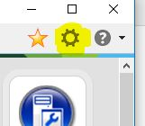
4. Click on “Sharing”, then “Add”

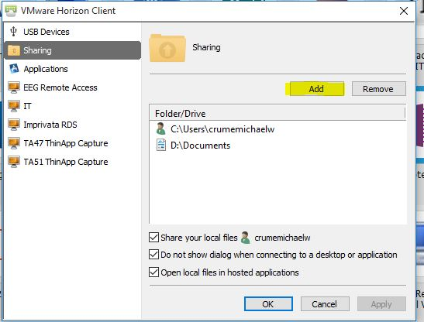

1. This will bring up a list of locations available to your computer.

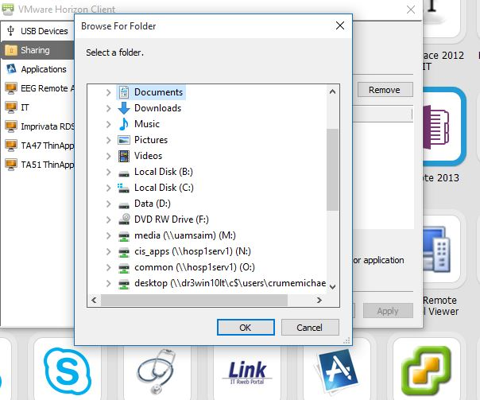

Local Drive:

Select where you want to save your Documents. In this example, I selected “Documents” so it will save to my “Documents” folder on my local “D” drive.

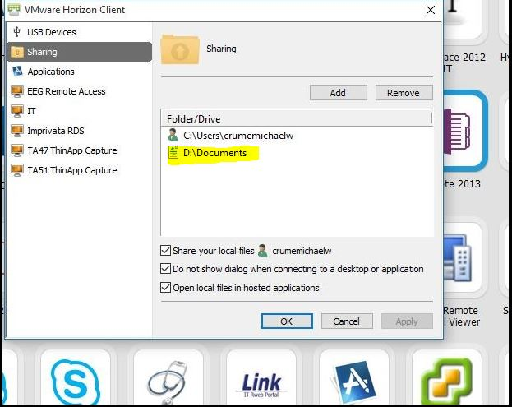

**Network Drive:**

Repeat steps 1-5 from above.

Select the drive you want to add, then the folder.

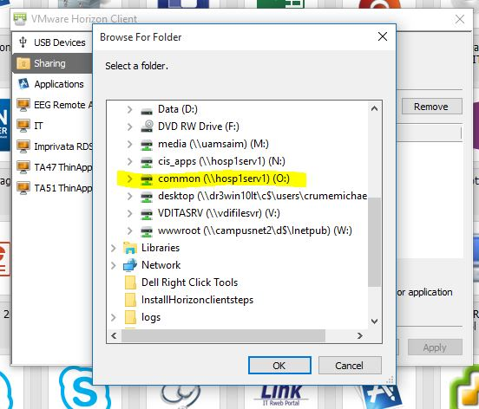

**Click “Add”, then “Ok.**

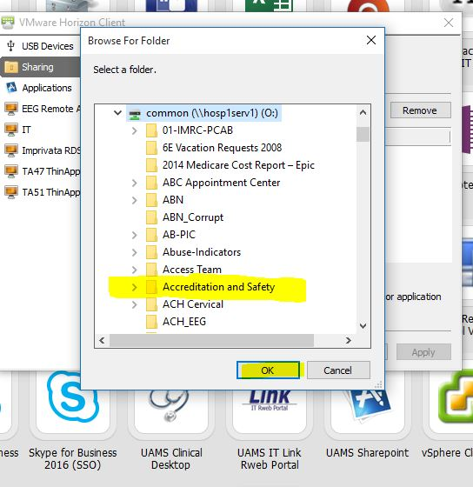

**Saving a file:**

To save a file such as a Microsoft Word Document, open the document from MyDesk or Horizon client and complete your document.

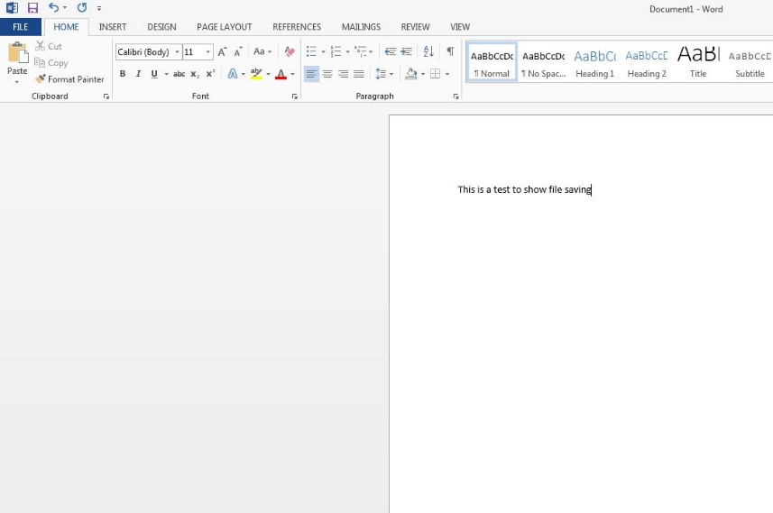

Once complete, click “Save”. This will bring up a dialog box:

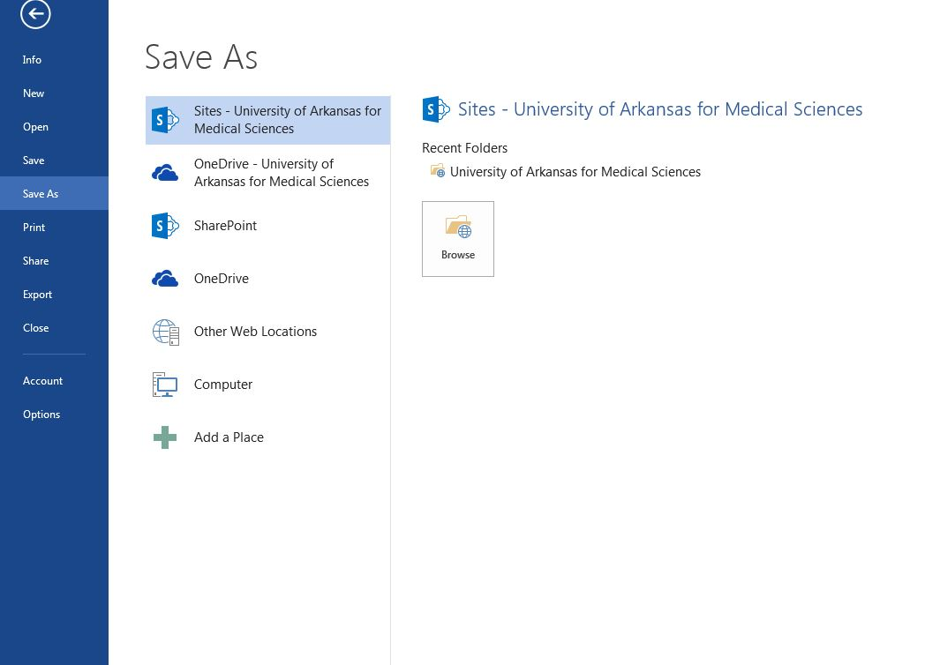

Click “Browse” and then select the location you want to save the file. Select the drive on the left pane and name your file.

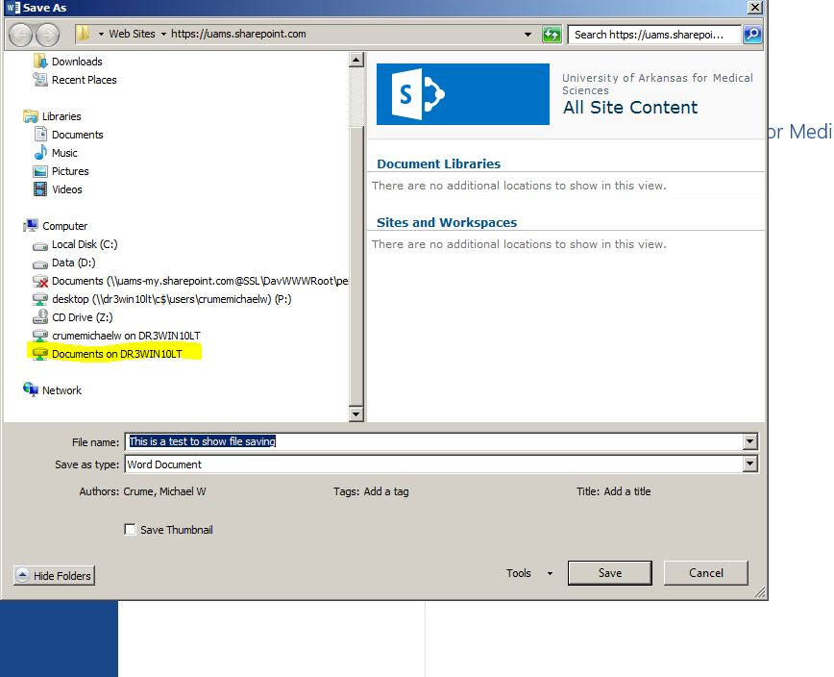

Click “Save”